1. Agenda:
   1. Relationship b/w Hibernate and JPA.
2. 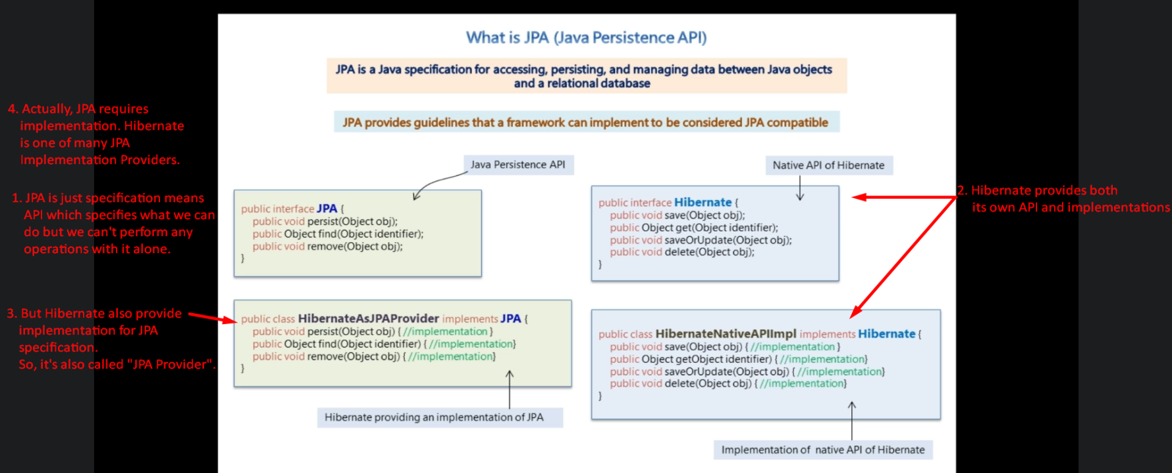
3. Hibernate:
   1. Hibernate is more than just JPA Provider, it provides plenty of non-JPA things which are quite useful.
   2. Unless you have a good reason, there is no point of restricting yourself to just JPA when using Hibernate.
   3. We might use Hibernate API and use its full power.
   4. How we can use Hibernate non-JPA features while using it as JPA provider?
   5. Just by getting access to underlying Hibernate API.
   6. By using unwrap() provided by JPA to access Hibernate Session Factory.

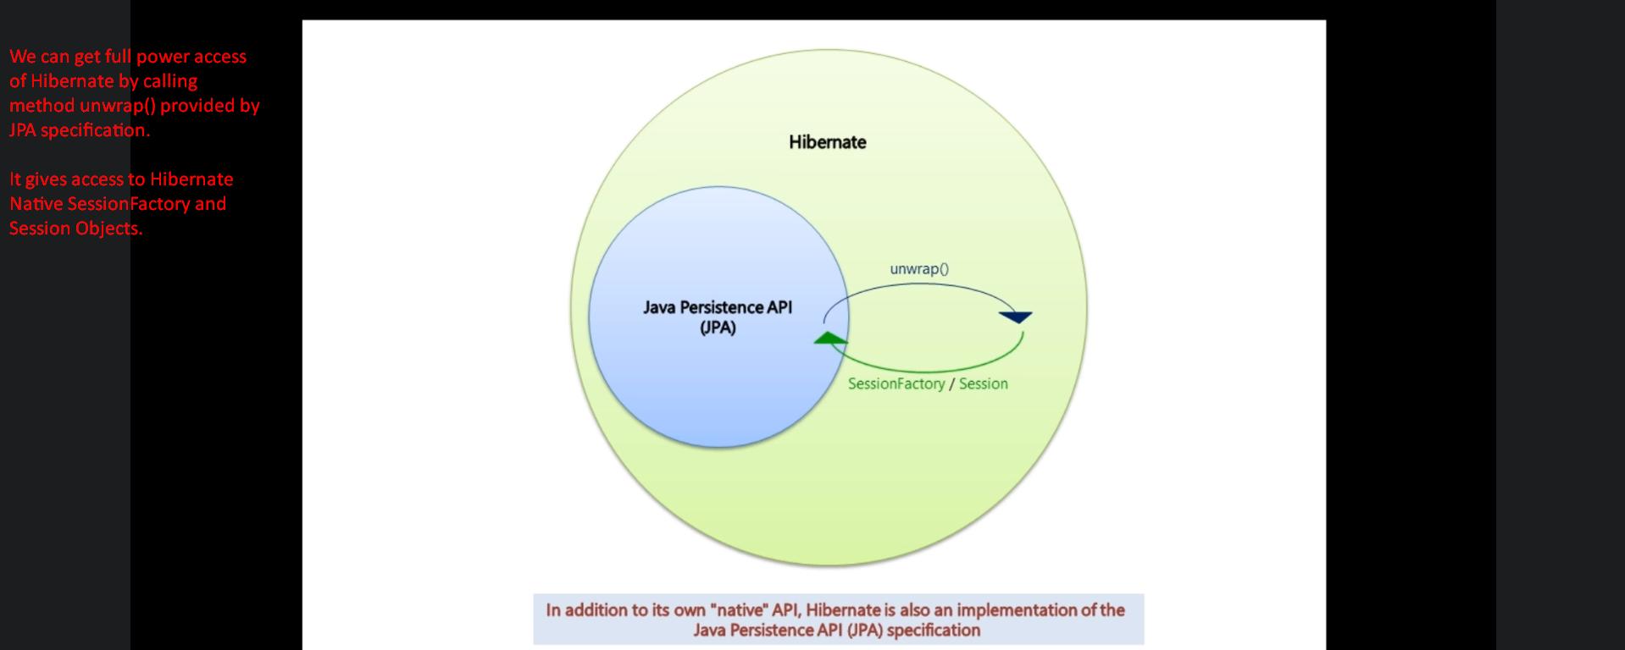

1. **Question**: You may ask what is the purpose of JPA when we hibernate which can take care of mapping and persisting objects.
2. 